

High Level Document

**Borrowing Management**

# Introduction

* + Overview
* Borrowing Management API to manage user & admin operations.
* Objective
* Provides HLD for Borrowing Management API.
* In scope
* JUnit partial coverage
* Logging
* Caching
* Exception Handling
* Security partial coverage
* Containerization
* Out of scope
* JUnit full coverage
* Testing Metrics
* Security full coverage for Authentication & Authorization + JWT

# Used Technologies

* Web
* Spring Rest
* Spring Data
* Spring Boot
* Spring Cache
* Spring AspectJ
* Spring Security
* Web Server
* Spring Boot Embedded Tomcat
* Database
* PostgreSQL
* Source Control
* GitHub
* SW Project Management Tool
* Maven
* Unit Testing Framework
* Spring Test
* Containerization
  + Docker

# Source Code

https://github.com/AbdElHalimHeba/MaidsRepo.git

# ER Diagram

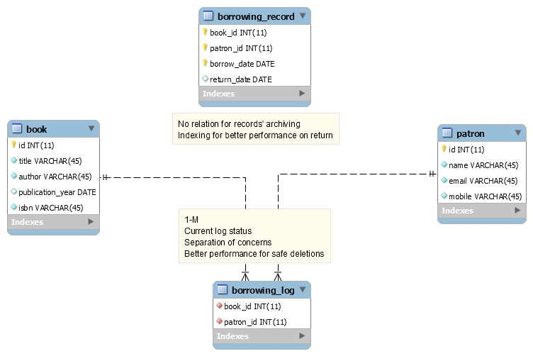

# Running Instructions

* Open bash shell

Network

* Create a shared network between containers:

docker network create spring-network

PostgreSQL DB

* Change directory to maids\src\main\docker\db to build PostgreSQL DB image:

docker build -t postgre_db .

* Run PostgreSQL DB container:

docker run -d --network spring-network -p 5432:5432 --name db postgre_db

Redis Cache

* Change directory to maids\src\main\docker\cache to build Redis Cache image:

docker build -t redis_cache .

* Run Redis Cache container:

docker run -d --network spring-network --privileged -p 6379:6379 --name cache redis_cache

Spring boot application

* Change directory to maids to package Spring Boot application & copy jar from target to src/main/docker:

mvn clean package

cp target/Maids-0.0.1-SNAPSHOT.jar src/main/docker

* Change directory to src\main\docker to build Spring Boot application image:

docker build -t maids .

* Run Spring Boot application container:

docker run -it --network spring-network -p 8080:8080 --name app maids